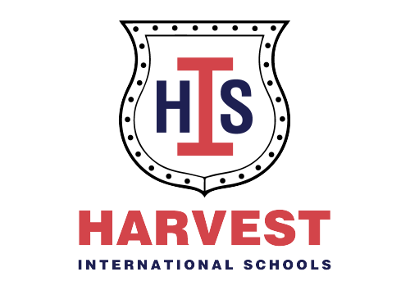
Harvest International School
IF Department
IF 1
Newsletter
From 24/9 to 27/9
- English
Oral sounds: s, a, t
Blending words: sa & sat
Tricky words: I & the
Course book: unit 1 (Hello)
Vocab: teacher, welcome, in, on, under, cars, teddy, toy, box& shoes
Structure: Hello/ How are you?/ I am fine thank you/ it is nice to Meet you.
C.W: Tracing sheets
- Math
Number: 1
Colour: red
Shape: circle
Counting oral: 1-5
Skills: positions & slide or roll
C.W: Collins book p. 12 & 15
H.W: worksheets
- Nursery rhyme
If you’re happy
(https://youtube.com/watch?v=l4WNrvVjiTw&feature=shared)

- Activity
Slide or roll game

