Name : …………….. Date:……………………….
Class :…………………..
Weekly Assignment(2) habitats
Choose the correct answer :
1-Cactus plant live in which habitat ?
a-arctic ocean b-forest
c-jungle d-desert
2-What is habitat ?
a-a plant or animal’s favourite food
b-something a plant or animal likes to do for fun
c-the natural home for a plant or animal
3-What is the weather of the desert ?
a-wet and hot
b-wet and cold
c-dry and cold
d-dry and hot
4-Which plant grow in a desert ?
a-cactus plant
b-seaweed
c-trees
d-flowers
5- All habitats are the same ?
a-true
b-false
6- Plants grow in …………… places .
a-different b-same
7- Every plant has its own habitat ?
a-yes
b- no
8- What is the condition of rainforest ?
a-hot and wet
b-cold and dry
c- cold and wet

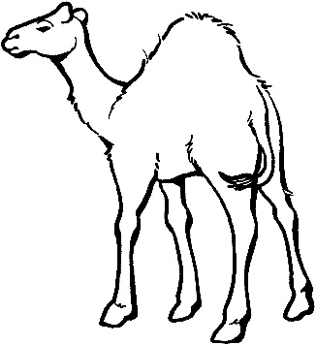
Complete the following:
(camel-hot and dry – desert - cold – hump)
1-It’s a …………………
2- It lives in ……………………..
3- It stores my food in its ………………
4-It can’t live in …………… weather.
5- The weather of its habitat is …………….. and ………………..

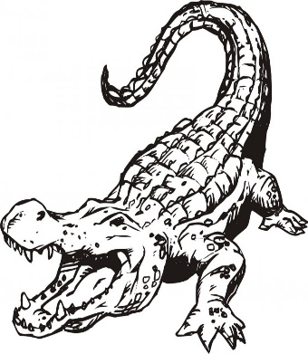
Complete the following :
(alligator – swamps-wild)
1-It’s an ………………..
2- It lives in …………………
3- It’s a ……………. animal.

