Harvest International School
Name ………….. American Division
Grade 2 Quarter 3
Weekly Quiz 2 * English *

Choose
1- The word Sit has ……..
-long i
- short i
2- I don`t want to do all these tasks, I will make a …..
- Complain
- Conversation

3- My dad …….to get high marks in my quiz.
- Watches
- encourages

4- The word extreme has ………
- long i - short i
5- Yesterday, I was ………. because I had lots of HomeWorks.
- delighted
- grumbled

Correct the mistake in bold

1-Tom walk up everyday t 6 am.
2- I likes to eat pizza at lunch.
3- My cat drink all the milk.
4- My father and I encourage my little sister to study hard.
5- We are delighted to be in a dark and scary place.

Write one of the following topics
1- A narrative story about a prince who is turned into a girl.
2- A girl who likes to do0 a new adventure.
Please use the present simple tense in the whole paragraph

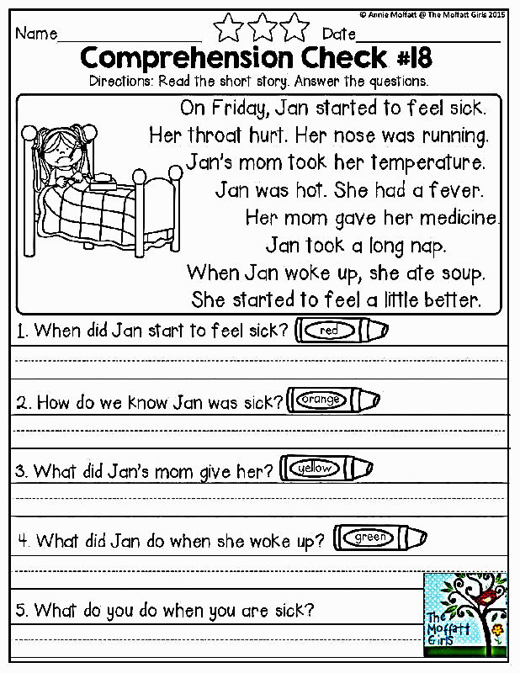

Correct
1- Tom walk up every day at 6 am.
2- I likes pizza so much.
3- My cat drink all the milk .
4- We can watch the sky indoor while we are in the tent.

Write one topic from the followings.
1- A narrative story about a prince who is turned into an ugly girl.
2- A girl who likes to do a new adventure.
( Use the present simple tense in the whole story – show your brainstorming

