
Harvest International School
American Division
Name ……………………. English Grade 2
Weekly Quiz 5

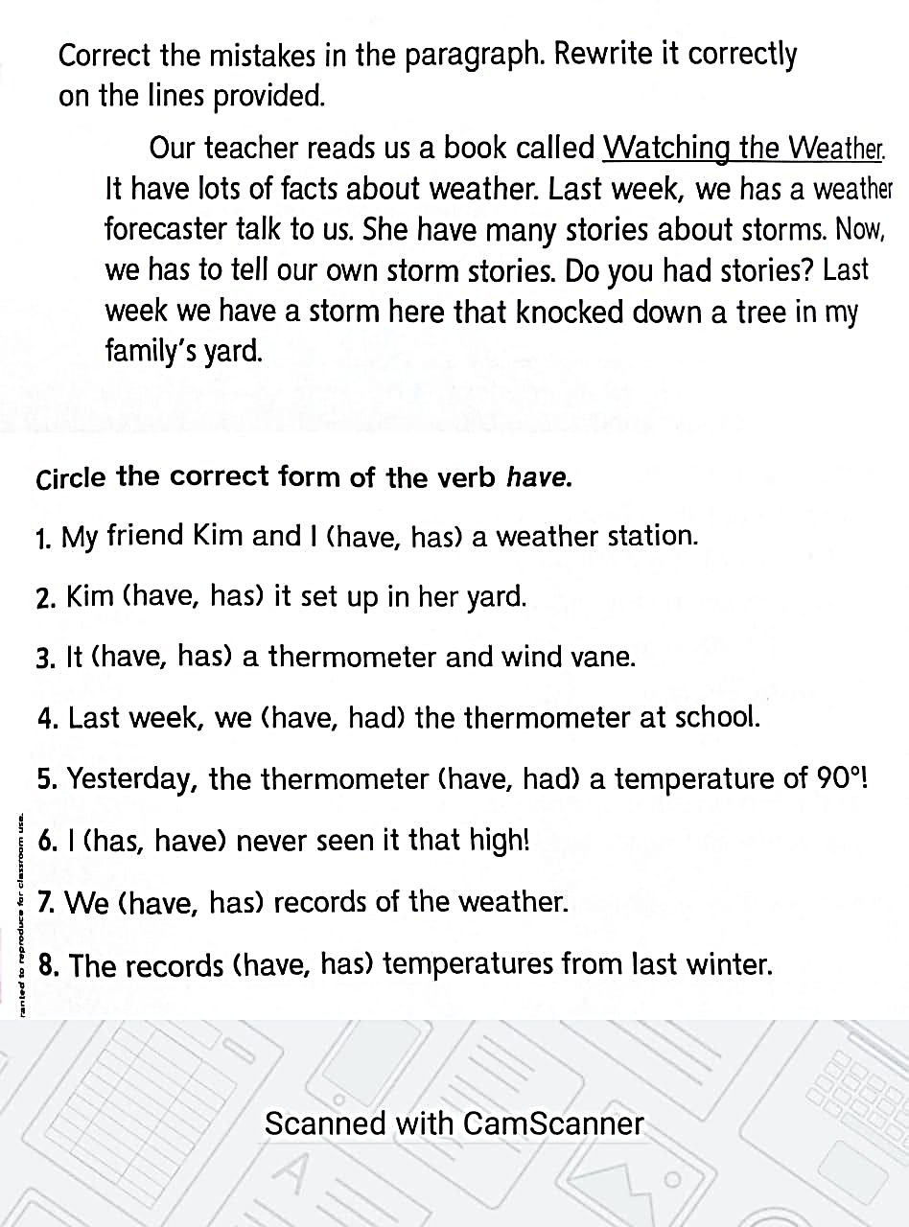

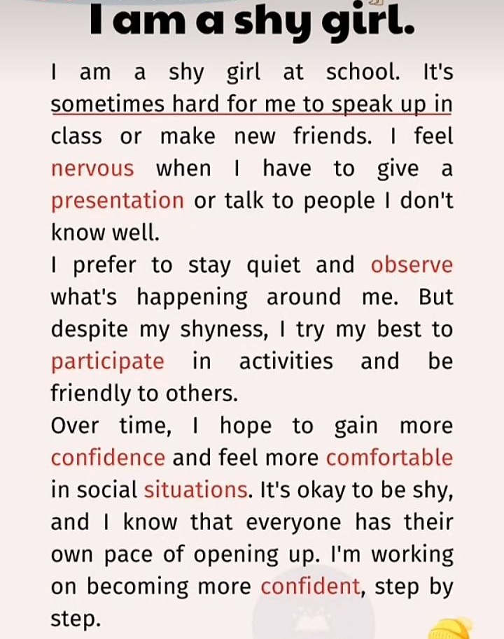

Answer the following questions based on what you have read in the above reading text
1- A synonym of speak up is ………
(participate – sleep – be noisy)
2- Get from the text, the noun of the adjective confident is………………
(conversation – conference – confidence)
3- Being shy, it is …………… to make new friends.
(easy – hard – heavy)
4- - A synonym of comfortable is ………...
(sleepy – cozy- easy)
5- the word observe means ……….
(speak – walk – notice carefully)

Answer the following questions
1- What does she do despite her shyness?
…………………………………………………………………………………………………………………………………………………………………………………………………….
2- What does she prefer to do?
…………………………………………………………………………………………………………………………………………………………………………………………
Correct the mistake
1- I will do my homework when I go home.
This sentence is in the past tense.
2- Ali and Tom has green eyes.
3- yesterday, I watch a new American movie.
4- Tomorrow, I went to the club with my friend.
5- Her and hair are synonyms.
6- cozy and comfortable are homophones.
7- Every day, I visited my grandma.
8- We celebrate the new year in China last year.
9- the word cute has short/ u/.
10- the word week short/ e /.

