
Harvest International School
American Division
Full Name ………………………. Grade 2 English
Final Revision for Quarter (4)

Revision 1
Reading Passage:
The Little Red Hen

Once upon a time, there lived a little red hen in a farmyard. She found some grains of wheat. She asked the other animals, "Who will help me plant these grains of wheat?"
"I will not," said the dog.
"I will not," said the cat.
"I will not," said the duck.
"Then I will do it myself," said the little red hen. And she did. She worked hard in the field, planting the grains of wheat.
When the wheat grew tall and strong, the little red hen asked again, "Who will help me harvest the wheat?"
"I will not," said the dog.
"I will not," said the cat.
"I will not," said the duck.
"Then I will do it myself," said the little red hen. And she did. She harvested all the wheat by herself.
Next, the little red hen asked, "Who will help me take the wheat to the mill to grind it into flour?"
"I will not," said the dog.
"I will not," said the cat.
"I will not," said the duck.
"Then I will do it myself," said the little red hen. And she did. She carried the heavy sack of wheat to the mill and ground it into flour.
Finally, the little red hen asked, "Who will help me bake the bread?"
"I will not," said the dog.
"I will not," said the cat.
"I will not," said the duck.
"Then I will do it myself," said the little red hen. And she did. She baked the bread all by herself.
When the delicious smell of fresh bread filled the air, the other animals came running. "We will help you eat the bread!" they exclaimed.
But the little red hen shook her head and said, "No, I will eat the bread all by myself. I planted the grains, I harvested the wheat, I ground it into flour, and I baked the bread. So, I will enjoy it all alone."

Choose from the following answers

- Who found the grains of wheat?
  - A) The dog
  - B) The cat
  - C) The little red hen
  - D) The duck

- Who helped the little red hen plant the grains of wheat?
  - A) The dog
  - B) The cat
  - C) The duck
  - D) Nobody
- Who refused to help the little red hen at every stage?
  - A) The cat
  - B) The duck
  - C) The dog
  - D) All of the above
4.What did the little red hen bake?
  - A) Cake
  - B) Cookies
  - C) Bread
D) Pie
5.Why did the little red hen decide to eat the bread by herself?
  - A) Because she was selfish
  - B) Because she was tired
  - C) Because she did all the work
  - D) Because she didn't like to share

Choose from the following answers.

- What is the capital of France?
- A) Paris B) London C) Rome

- What is the name of the planet we live on?
- A) Mars B) Venus C) Earth

3. If you put “they” and “are” together, it makes the word …
a- theyare b- theyre c- they’re

4/ Which of the following words means “on the day before this day”?

a- tomorrow b- yesterday c-yesterday

5.One day last year John ___________ for his mom at the front door.

a- will wait b-waited c- waits

6. . Many animals will _______ in the cold.

a- dead b- die c-died

7. No one _______ the future for sure, of course.

a- will knew b- knows c-know

8. The firefighters _____________ her.

a-rescues b- rescued c- will rescued

9. which word has long e ……………..
a- slept b- deer c- bag

10- which verb is in the past simple tense………..
a-goes b- will go c- went

Find synonyms to the underlined words in these sentences.

1. She was so happy to be home.
2. yesterday, I was playing with a group of children.
3. When he was 16, he took a long bike trib.
4.comparing to ants, elephants are very big animals.
5. we are a bit grumbled as we have lots of tasks.

choose whether the following questions are true or false∶

1.The word "cake" has a long A sound.

2.The word "box" has a short O sound.

3.The word "pot" has a short O sound.

4. The car is almost out of fuel, that’s why it is not moving.

5.Sam is pleased ,so he is crying.

6. yesterday, Lina goes to the pool with her child.

7. The word spoon has long o.

8. My sister and I watched a movie next Friday.

Imagine that you are an animal. Which animal would you like to be? and why?
Create a story about your experience if you could be an animal for just one day.

………………………………………………………………………………………………………………………………………………………………………………………………………………………………………………………………………………………………………………………………………………………………………………………………………………………………………………………………………………………………………………………………………………………………………………………………………………………………………………………………………………………………………………………………………………………

Revision 2

The Friendly Forest

Once upon a time, there was a magical forest called Greenwood. In Greenwood, all the animals lived together in harmony, helping each other whenever they could.
One sunny morning, Lily the rabbit woke up early to gather some berries for breakfast. As she hopped through the forest, she heard a faint cry for help. Curious, she followed the sound and found Timmy the squirrel stuck in a bush, his tail tangled in some branches.
"Lily, help me, please!" Timmy pleaded.
Without hesitation, Lily hopped over and carefully untangled Timmy's tail from the branches. Timmy thanked Lily, and they both continued on their way, chatting and laughing as they went.
Later that day, Lily encountered a group of ants struggling to carry a large apple back to their nest. Seeing their struggle, Lily offered to help. Together, they lifted the apple and carried it back to the ant's nest, where they shared it with the entire colony.
As the sun began to set, Lily returned home feeling happy and fulfilled. She knew that in Greenwood, no one was ever alone, and everyone looked out for each other.

Choose from the following

1- What is the name of the magical forest in the story?
a) Greenleaf
b) Greenwood
c) Greentree
d) Greenhill

2-Who did Lily encounter stuck in a bush?
a) Tommy the rabbit
b) Timmy the squirrel
c) Terry the turtle
d) Tammy the fox

3-What was Timmy's tail tangled in?
a) Leaves
b) Branches
c) Flowers
d) Grass

4-How did Lily feel at the end of the day?
a) Sad
b) Angry
c) Happy
d) Frustrated

5-What did Lily help the ants carry?
a) A watermelon
b) A strawberry
c) An apple
d) A banana

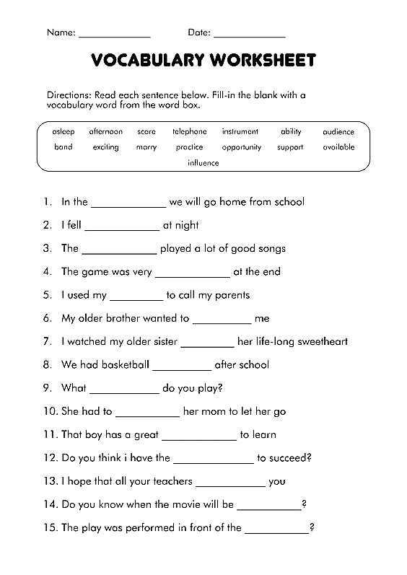

Choose from the Following Answers

1- we didn’t ……………… our relatives last week.
- Visited
- Visit
c- visits

2- Ann ………… like to watch horror movies.
- Doesn’t
- Don’t
- Do

3- ……………..., I go to school at 8 am.
- Yesterday
- Everyday
- At night
4- 1. The word hat has ……….
A- short a
B- long a
c- long t

5- Tom got low marks in his exam, he is ……………

- Disagreed
- Disappointed
- disabled

6- Nancy …………. Want to sleep early.
- Don’t
- Doesn’t
- Doesnt

7- My child is ……………. In the pool, he is so glad.
A-Splashing
B-Slashing
c-sleeping

8- This picture cannot be …………………..
A-captured
B-done
c-took

Writing

Write a paragraph about your future job.
……………………………………………………………………………………………………………………………………………………………………………………………………………………………………………………………………………………………………………………………………………………………………………………………………………………………………………………………………………………………………………………………………………………………………………………………………………………………………………………………………………………………………………………………………………………………………………………………………………………………………………………………………………………………………………………………………………………………………………………………………..
…………………………………………………………………………………………………………………………………………………………………………………………………………………………………………………………………………………………………………………………………………………………………………………………………………………………………………………..………………………………………………………………………………………………………………………………………………………………………………………………………………………………………………………………………………………………………………………………………………………………………………………………………………………………………………………………………………………………………………………………………………..

Revision 3
Read the following reading comprehension text

Don’t Give Up

If you’ve tried and have not won, never stop crying; All that’s great and good is done Just by patient trying.

Though young birds, in flying, fall, still their wings grow stronger; And the next time they can keep Up a little longer.

Though the sturdy oak has known Many a blast that bowed her, she has risen again, and grown Loftier and prouder.

If by easy work you beat, Who the more will prize you? Gaining victory from defeat -- That’s the test that tries you!

Answer the following Questions.

1. What is ‘done by patient trying’? ____________________________________________________________________________________________

2.What happens to young birds when they fly? _________________________________________
……………………………………………………………………………………………………………………………..

3. What does the sturdy oak do after being bowed? ________________________________________________

………………………………………………………………………………………………………………………………

4.What is the test that tries you?

………………………………………………………………………………………………………………………………………………………………………………………………

Choose from the following Answers.

1. Which word has the same ending sound as "rug"?
- A) Cap
- B) Bug
- C) Cat
- D) Box

2.We should …………… and help each other.

- Unite
- Uniform
- unique

3.Our golden …………….. is treat people the same way we would like to be treated.

- Tool
- Rule
- Fuel

4. Which word has the same sound as "sun"?
- A) Moon
- B) Star
- C) son

5. Which word ends with the same sound as "cat"?
- A) Dog
- B) Bed
- C) hat

6- It is an …………………………... to hike in the woods.

a-trip
b-vacation
c-adventure

7- Which tense is used to describe Timmy's past actions?

a) Present simple
b) Past simple
c) Future simple

8- What does "gentle" mean?
- A) Rough
- B) Kind and not harsh or violent
- C) Loud

9- What does ‘’serious’’ means ?

- Important
- Sad
- interesting

10- What does "bright" mean?
- A) Dark
- B) Shiny
- C) Sad

Choose whether the sentence is True of false

- Elephants have long trunks.

- The word clean has short e .

- Sally is sleeping so she is outside.

- History tells us about what will happen in the future.

- Jack is disappointed, he got high marks in his final exam.

- She is pleased, her laptop is stollen.

- We have to love each other.

- We have to cooperate to live happily.

- The past tense of the verb’ see’ is seed.

10-Anna had a question, so she exclaimed.

Writing

Write a Paragraph to explain what is something you love about yourself?

……………………………………………………………………………………………………………………………………………………………………………………………………………………………………………………………………………………………………………………………………………………………………………………………………………………………………………………………………………………………………………………………………………………………………………………………………………………………………..
………………………………………………………………………………………………………………………………………………………………………………………………………………………………………………………………………………………………………………………………………………………………………………………………………………………………………………………

Revision 4

The Lost Kitten
Once upon a time, there was a little girl named Sarah. Sarah loved animals, and she had a cat named Whiskers.
One sunny day, Sarah took Whiskers for a walk in the park. Whiskers was playing happily when suddenly, he saw a butterfly and chased after it. Sarah tried to catch Whiskers, but he was too fast and disappeared into the bushes.
Sarah looked everywhere for Whiskers. She searched under benches, behind trees, and even asked people in the park if they had seen him. But Whiskers was nowhere to be found.
Feeling sad and worried, Sarah sat down on a bench and started to cry. Just then, she heard a tiny "meow" coming from behind a bush. Sarah rushed over and found Whiskers hiding there.
She hugged Whiskers tightly and said, "Oh, Whiskers, I was so worried about you! I'm glad I found you."
Whiskers purred happily and licked Sarah's cheek. From that day on, Sarah made sure to keep Whiskers on a leash whenever they went for walks in the park.
And they lived happily ever after.

Choose from the following answers!

1-What is the name of the little girl in the story?
a) Lily b) Sarah c) Emily

2-What is the name of Sarah's cat?
a) Whiskers b) Fluffy c) Mittens

3-Where does Sarah take Whiskers for a walk?
a) Beach b) Park c) Forest

4-What does Whiskers chase after in the park?
a) Butterfly b) Bird c) Squirrel
d) Rabbit

5- What does Sarah do after finding Whiskers?
a) Leaves him in the park
b) Takes him home immediately
c) Scolds him for running away
d) Hugs him tightly

6- How does the story end?
a) Sarah and Whiskers get lost in the park.
b) Sarah finds a new kitten to play with.
c) Sarah and Whiskers live happily ever after.
d) Whiskers runs away again.

All About My Mom
My mom’s name is …………………………… . She is ……………………..years old. She was born in………………………………………. . My mom’s favorite food is …………………………. In her free time, my mom enjoys ……………………………………………. During the day, my mom ……………………………………... My mom’s best qualities include …………………………………………………………………………………… My favorite memory with my mom is……………………………………………………

Draw a picture of your mom in the frame

Fill in the missing form in the correct tense

  - Walter ………………..( go) to school last week.

  - What did you ……………….. (do) last night?

  - Sally …………… (go) to school every day.

  - I ……………………………. (travel) to France next winter.

  - We know that the sun ………………..(rise) from the east.

  - What ………………you……………..(do) next vacation?

  - Yesterday, we ………………….(not/watch) cartoon before we sleep.

  - My children ……………… (sleep) early last night.

  - We ………………… (celebrate) our anniversary on 2025.

  - My brother usually……………….(watch) horror movies.

Choose From the Following answers.

  - Last night, we …………… brush our teeth.
(do / didn’t / does)
  - Next week, My parents …………... to China.

(will travel / travels / travelled)
  - My classmate always …………… ……. Books in the break time.
(read / reads / reed)

  - Which word has the long e ……….
(cheer / chair / chief)

5-My mother and I usually …………… together.
(cooks / cook / cock)

6-Which word has short i …………...
(hop / hippo / here)

Writing

- White a paragraph about Which celebrity would you like to meet and why? Write to that person about why you admire them and what you would ask if you met them.

……………………………………………………………………………………………………………………………………………………………………………………………………………………………………………………………………………………………………………………………………………………………………………………………………………………………………………………………………………………………………………………………………………………………………………………………………………………………………..
……………………………………………………………………………………………………………………………………………………………………………………………………………………………………………………………………………………………………………………………………………………………………………………………………………………………………………………………………………………………………………………………………………………………………………………………………………………………………………………………………………………………………………………………………………………………………………………………………………………………………………………………………………………………………………………………………………………………………………………………………………………………………………………………………………

Revision 5

The Rainbow Fish

Once upon a time, in the sparkling ocean, there lived a beautiful fish named Rainbow Fish. Rainbow Fish had shiny, colorful scales that glittered in the water.
One day, Rainbow Fish was swimming happily with his friends when a small blue fish asked, "Rainbow Fish, can I have one of your shiny scales?"
Rainbow Fish frowned and replied, "No, I can't give you my scales. They make me beautiful."
The small blue fish swam away sadly, and Rainbow Fish felt a little guilty.
Later, Rainbow Fish saw the other fish avoiding him. He felt lonely and realized that having shiny scales wasn't as important as having friends.
Rainbow Fish found the small blue fish and said, "Here, take one of my scales."
The small blue fish's eyes lit up with joy as he accepted the shiny scale. He thanked Rainbow Fish and swam away happily.
Soon, the other fish started to approach Rainbow Fish again. They admired his kindness and wanted to be his friend.
From that day on, Rainbow Fish shared his shiny scales with his friends, and they all swam together in the sparkling ocean, happy and content.

Choose from the following
- What is the name of the main character in the story?
a) Blue Fish
b) Rainbow Fish
c) Goldfish
d) Silver Fish

  - What makes Rainbow Fish special?

a) His colorful scales

b) His big eyes

c) His long tail

d) His fast swimming

  - Why does the small blue fish ask Rainbow Fish for one of his scales?

a) To make himself beautiful
b) To use it as a toy
c) To play a trick on Rainbow Fish
d) To eat it for food

4-Why does Rainbow Fish feel lonely later in the story?
a) Because he loses all his scales
b) Because his friends stop talking to him
c) Because he can't find food to eat
d) Because he gets lost in the ocean

5-What does Rainbow Fish realize about having shiny scales?
a) They are very heavy.
b) They are not important.
c) They make him swim faster.
d) They make him invisible.

. Multiple Choice Questions

1. The cats ----------- the tree.

a- climb b- climbs

2- He ----------------- football every day.

a- plays b- played

3-The driver--------- the bus.

a- drive b- drives

4- Which word has the long "o" sound?
a) Cat b) Bone

5- Choose the word with the short "e" sound:
a) Hen b) Bone

6- Which word has the short "e" sound?
a) Dog b) Net

7- Identify the word with the short "o" sound:
a) Home b) dog

8- Mary …………….. a long brown hair.

a- has b- have

9- we can …………… our room before my mom comes.

a- cleaned b- clean

10- Next week, we …………… move to another city.

a- would b- will

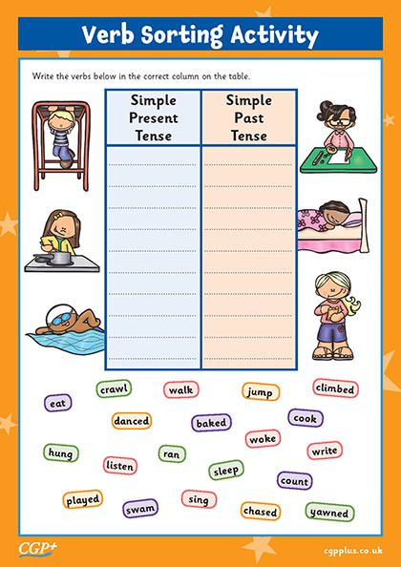

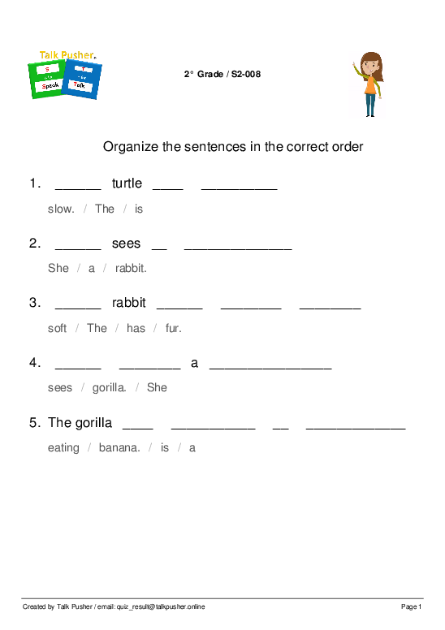
Writing

Write a paragraph about your plan for the next summer vacation.

…………………………………………………………………………………………………………………………………………………………………………
……………………………………………………………………………………………………………………………………………………………………………………………………………………………………………………………………………………………………………………………………………………………………………………………………………………………………………………………………………………………………………………………………………………………………………………………………………………………………..
…………………………………………………………………………………………………………………………………………………………………………………………………………………………………………………………………………………………………………………………………………………………………………………………………………………………………………………………………………………………………………………………………..
………………………………………………………………………………………………………………………………………………………………………………………………………………………………………………………………………

Revision 6

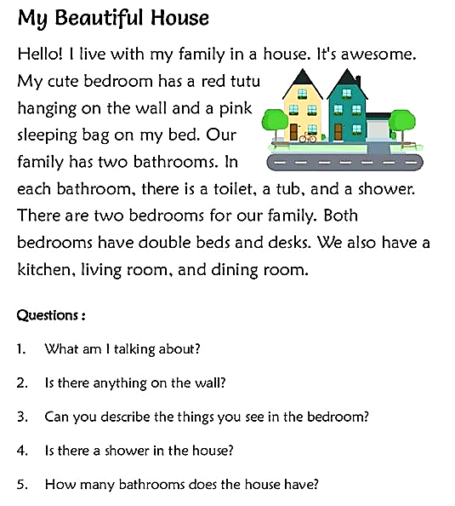

Fill in the blanks from the following vocabulary

(Disabled – write – did – where – what – camp – able - clever)

    - ………….. did you go last Friday?

    - We went to the ……………... yesterday.

    - Mark is ……………., he cannot walk probably.

    - My child used to …………… interesting stories.

    - What ……………. You do in your exam?

    - Maria is …………... to speak French.

    - ……………. do to go every day after school?

    - My son is so ………………, he always gets high marks in his final exams.

Choose from the following answers

1-January is than May.

- Cold

- Colder

- coldest

2- Mindy saw ant crawling on the ground.
- An

- A

- the

3- Identify the word that should start with a capital letter.
- Flag

- Country

- America

4-If your teacher tells you to rewrite something, you………….
- write it again.

- write it for the first time.

- erase it.

5-‘’Tom has small nose ‘’ The linking verb in this sentence is ……………..

a. has

b. have

c.had

6- Thomas ………………………. To the music.

a. dance

b. danced

c. moved

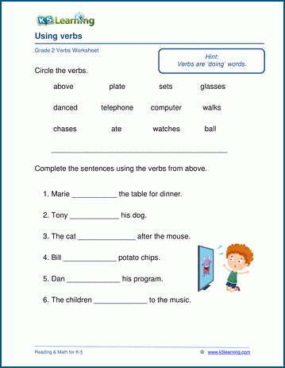
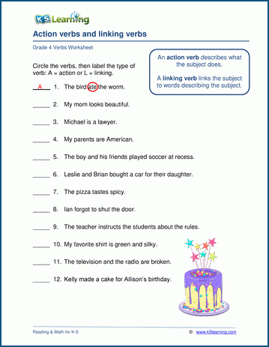
Writing

Assume you have a time machine. When and where would you travel? Create a narrative about your experience.

……………………………………………………………………………………………………………………………………………………………………………………………………………………………………………………………………………………………………………………………………………………………………………………………………………………………………………………………………………………………………………………………………………………………………………………………………………………………………..
………………………………………………………………………………………………………………………………………………………………………………………………………………………………………………………………………………………………………………………………………………………………………………………………………………………………………………………………………………………………………………………………………………………………………………………………………………………………………………………………………………………………………………………………………………………………………………………………………………………………………………………………………………………………………………………………………………………………………………………………………………………………………………………………………………

