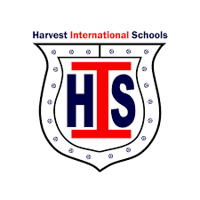
Harvest International schools
National Division

November Exam Timetable
Middle 2

Day/Date | Subject
Tuesday  26/11 | Arabic  Religion
Wednesday  27/11 | Science  ICT
Thursday  28/11 | Geometry  Art
Monday  2/12 | N.S
Tuesday  3/12 | English O.L  Algebra

