The model answers
ICT_ Year 4
For the Revision Sheet
1st term Exam2024/2025
Practical test:
Activity1:
Create the quiz program “ask the user a quiz question. Tell them if the answer is right.
A program plan sets out the inputs, processor and outputs of a program. Here is a plan for the quiz program.
• Input: Ask a quiz question and get the answer.
• Processor: Check if the answer is right
• Output: Tell the user if the answer is right
You will create a program to match this plan. (Using the Scratch programming language )
The solution:

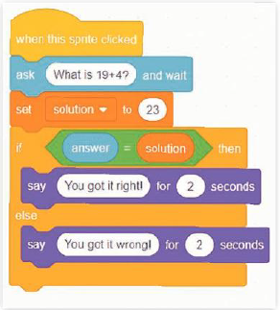
Activity2:
Make a computer game called Funny Jellyfish ‘A chase game’. Shark must swim and chase the Jellyfish using up, down, right, and left arrow
The solution:
The screenshot of the Shark code:
The screenshot of the Jellyfish code:

